Christopher Columbus Adventure Game: A Modular Client-Server Application Using Design Patterns
Northern Illinois University

Abstract
This project presents the design and development of the Christopher Columbus Adventure Game, a grid-based strategy game built using a modular client-server architecture. The backend is implemented in Java using NanoHTTPD, and the frontend is developed in React with TypeScript. The project focuses on applying object-oriented design principles and software design patterns, including Singleton, Observer, Factory, Strategy, Composite, and Decorator, to create a scalable and maintainable codebase. This document details the implementation strategy, UML diagrams, sequence flow, and testing approaches, serving as a comprehensive case study in software engineering best practices.

Keywords
Client-Server Architecture, Java, NanoHTTPD, React, Design Patterns, Game Development, UML, Software Engineering

Introduction
Interactive games provide a compelling medium to explore object-oriented principles, design patterns, and real-time state management. The Christopher Columbus Adventure Game challenges the player to find treasure while avoiding dynamically moving enemies like pirates and sea monsters. This project was undertaken as a final academic assignment to demonstrate proper modular design using advanced programming techniques.

System Design and Architecture
The system is composed of a Java-based backend server and a React + TypeScript frontend. The backend handles all game logic and uses REST APIs to communicate with the frontend. A central `GameState` singleton manages the grid, ship, monsters, and level tracking. The frontend renders the grid and receives updated game state via JSON responses.

Features and Functional Modules
The application includes the following major features:
- Larger dynamic grid with increased complexity.
- Columbus ship controlled via directional inputs.
- Pirates use different movement strategies (chasing, patrolling).
- Sea monsters created via factories and respond intelligently.
- Whirlpools randomly teleport Columbus to a different location.
- Decorator allows temporary enhancements to ship functionality.
- Game progression includes lives, scores, and increasing levels.

Design Patterns Used
The following six patterns were used and demonstrated via UML diagrams:

Composite Pattern
TileGroup class aggregates multiple TileComponent objects, allowing the game to treat multiple whirlpools as a unified entity.
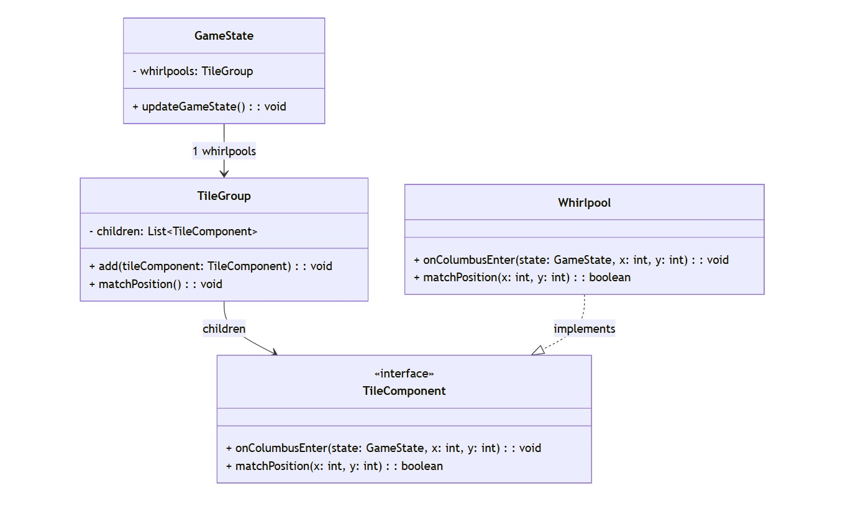

Singleton Pattern
GameState class ensures a single instance manages the shared game state across all modules.
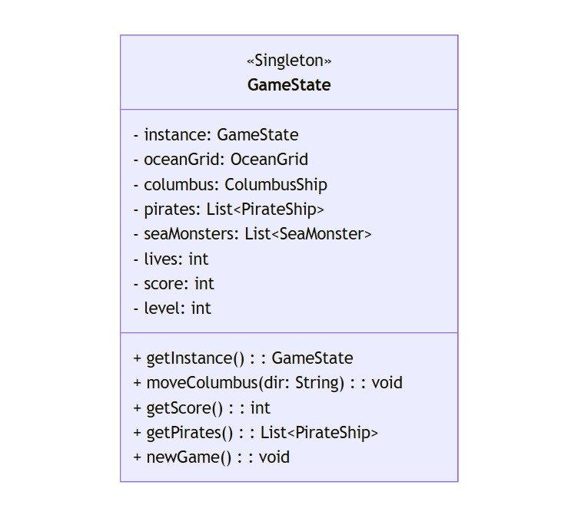

Factory Pattern
Sea monsters are created through abstract factories (e.g., SharkFactory, OctopusFactory) allowing polymorphic instantiation.
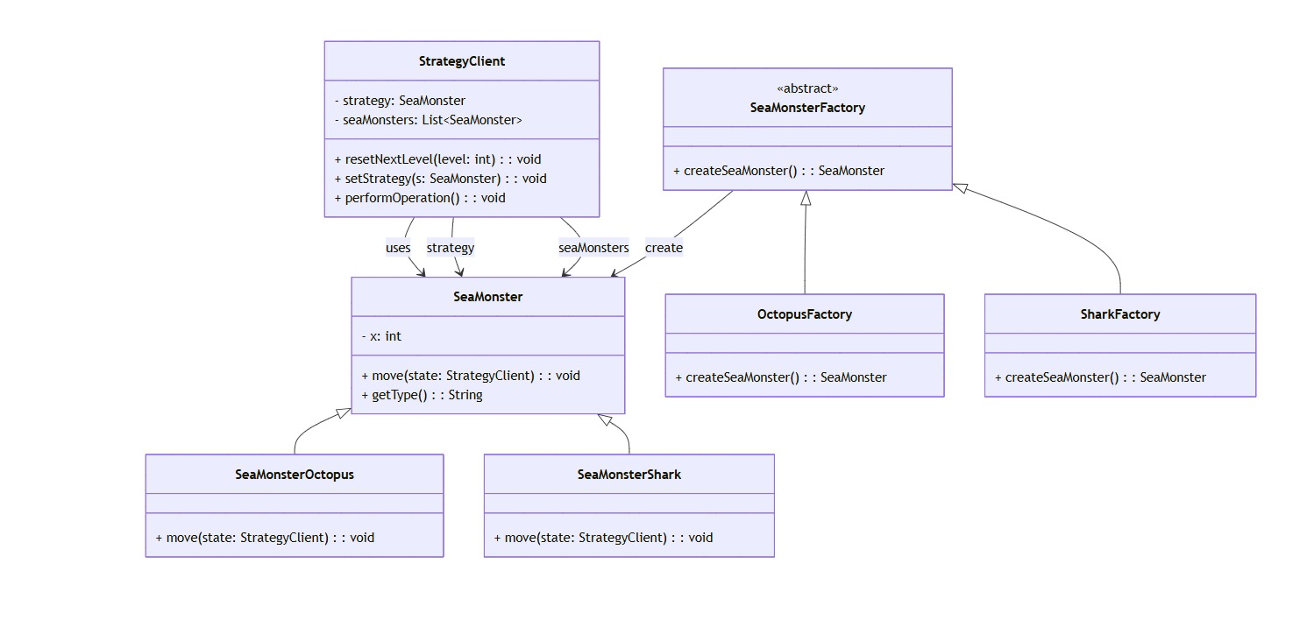

Observer Pattern
PirateShip instances observe the ColumbusShip and react to its movement in real-time.
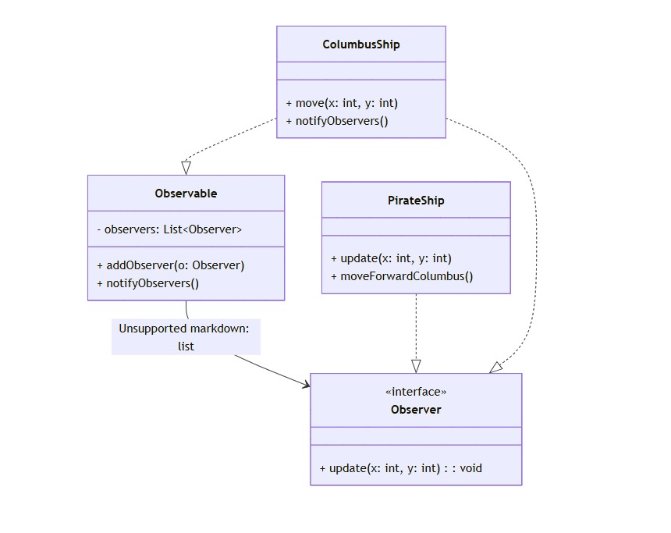

Strategy Pattern
Different behaviors for sea monsters and pirates are defined through interchangeable strategy classes.

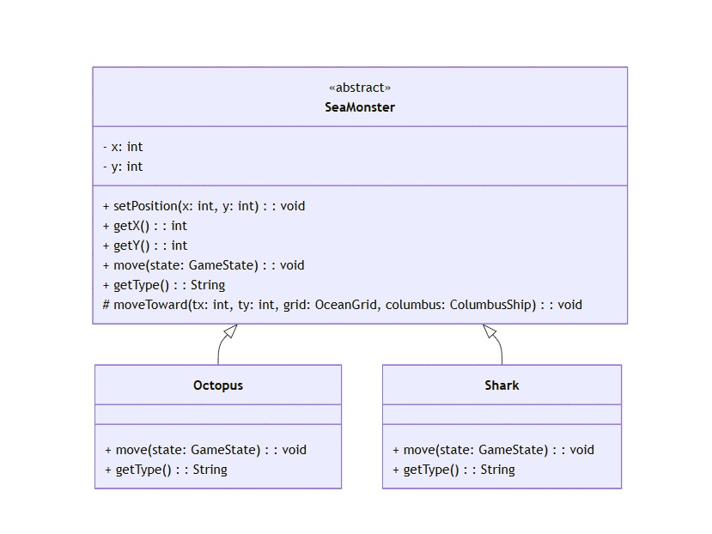

Decorator Pattern
ColumbusShip behavior can be dynamically enhanced using ShipDecorator subclasses such as WhirlpoolDecorator.
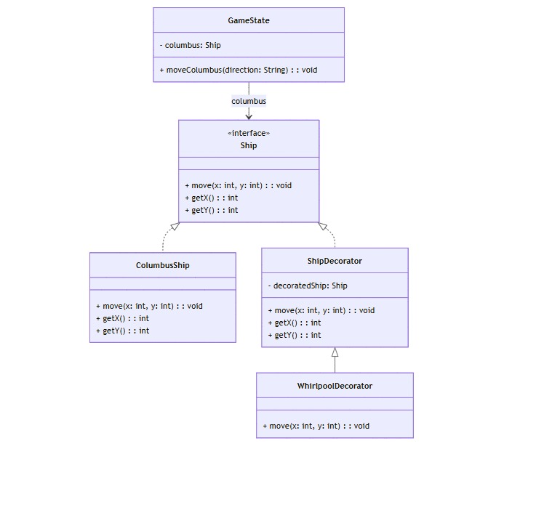

Integrated Class Diagram
The following UML diagram integrates all major classes and their relationships, showcasing how the design patterns interact in the system.
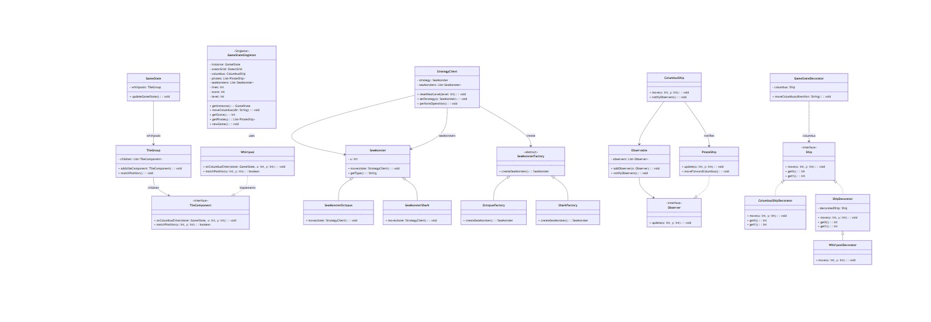

Sequence Diagram
The following sequence diagram illustrates the interaction flow when the user initiates a movement action. It shows backend logic, observer notification, and sea monster movement.
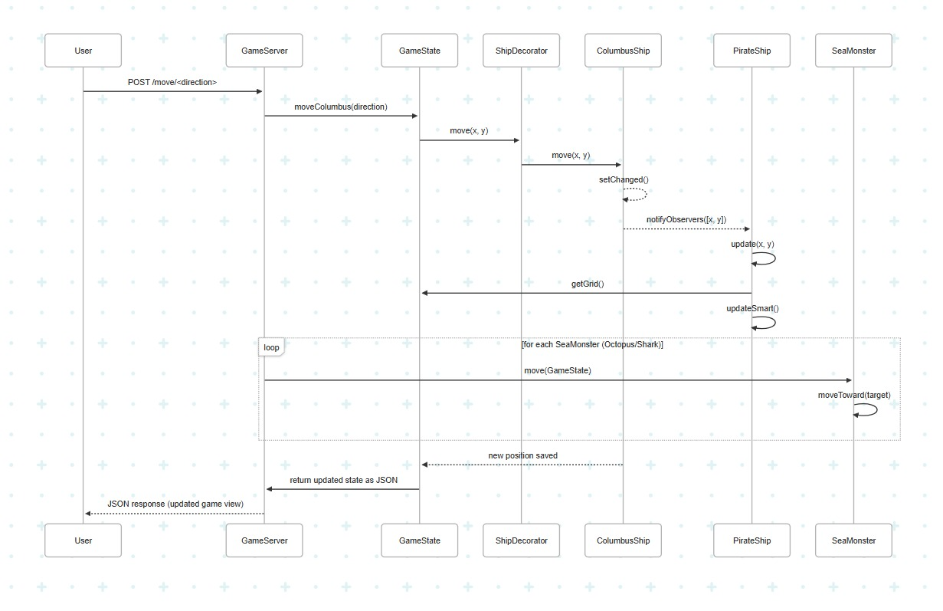

Testing
JUnit test cases were written for the following classes to ensure correctness of core functionality:
- GameStateTest: Validates the singleton nature of the GameState class, initial setup values, correct placement of Columbus and pirates, and progression to the next level.
- OceanGridTest: Tests grid boundary validation, island setting behavior, and ensures that invalid coordinates are handled properly.

The implementation successfully demonstrated modularity, reusability, and pattern-based design. Enemy behavior dynamically adapts to game state, and player experience improves with progressive levels. Challenges included implementing observer updates in real time and synchronizing state changes across the backend and frontend efficiently.
Git Commands :
1.git init
2.git add .
3. git commit -m "Comments"
4. git branch
5. git remote -v
6. git remote add origin https://github.com/CSCI-513-Spring25/final-project-group-projects-navya-lavanya/tree/main
7. git push -u origin master
Documentation:
Github Link:
https://github.com/CSCI-513-Spring25/final-project-group-projects-navya-lavanya/tree/main

Task Load :
Lavanya Neela:
Singleton Pattern
Factory Pattern
Decorator Pattern
Observer Pattern
Front-end , UI
Test -case - GameStateTest
PPT
UMLS
Documentation Report
NavyaSree:
StartegyDesignPattern
CompositeDesignPattern
Front-end - Story context
UMLs
Sequence diagram
Test-Case-OceanGrid

Conclusion
This project serves as a strong proof-of-concept for applying classical design patterns to interactive game development. The client-server architecture and modular structure pave the way for future extensions like AI-driven enemy behavior, multiplayer support, and additional design modes.

